Chapter 14, Solution 78.

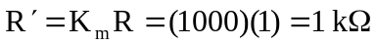
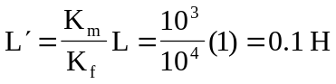
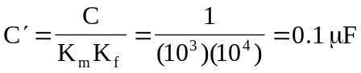

The new circuit is shown below.
1 kW
+
V_{x}
-
1 kW
0.1 H
I
0.1 mF
1 kW

